Guidelines for connecting to an Enterprise Server
In this course we will connect to the IBM Enterprise Class System using an Integrated Development Environment (IDE) called Rational Developer for System z (RDz.) RDz has three whys to connect to the system. First we will launch RDz. We can then connect with the enterprise system using a RDz facility called Host Connection Emulator Support. Follow these directions before attempting the class exercise.

- To launch RDz (if the light blue octagon is not on the desktop) open Rational Developer for System z by selecting it from Start menu → All Programs → IBM Software Delivery Platform → IBM Rational Developer for System z → IBM Rational Developer for System z.
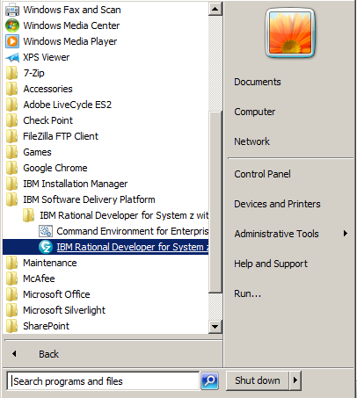

- When RDz is first launched it will prompt you for a workspace name. This is the file where RDz stores your workspace settings. You can have as many workspaces as you want depending on the type of work you do. It is normal to have only one. The workspace file remembers all of your settings as you use RDz and will take you where you left off after you close RDz and re-open it at another time.

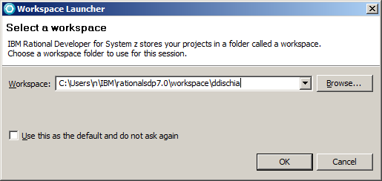

Change the location of this file from “C:\ ….” to either a flash drive or on your student drive. Name your workspace with your SU NetID and do not check “Use this as the default and do not ask again” box, then click OK.

Do not store your workspace on the iSchool lab computers since they are re-imaged on a regular basis so your workspace will get deleted. This shouldn’t be an issue since RDz will prompt you to create a new one the next time you launch RDz. But this workspace remembers the layout of your RDz user interface session so you will have to setup your connections to the enterprise system again.

Note: Keep in mind that if you store your workspace on this lab machine and if you change machines in this lab or use other lab facilities you will need to create a new workspace.

After you click ok you should see the Welcome screen below.
- Welcome - you should see a Welcome screen that looks similar to this. This screen does not appear in situations where you are not the first user to launch RDz on your workstation.

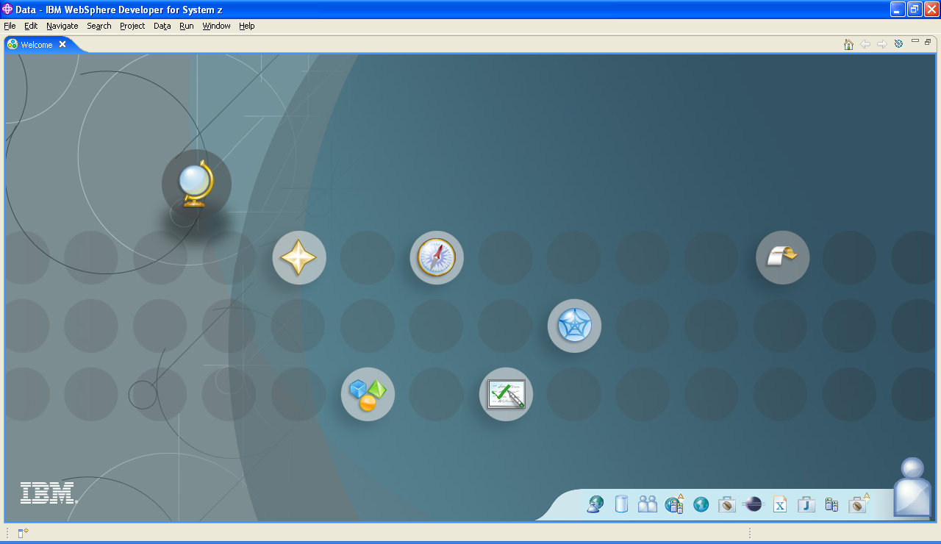

- If you don’t see this Welcome screen, you can display a similar Welcome screen by going to the main tool bar by selecting Help → Welcome.

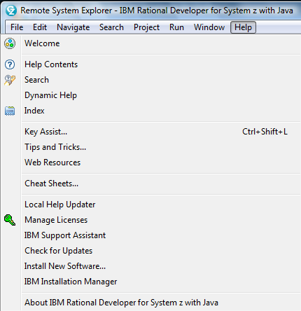
Once at the Welcome screen. You should see a screen that looks something like this:

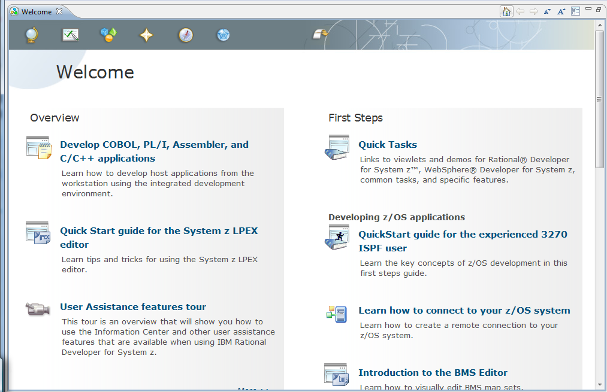

- To do work on the enterprise server or mainframe you need to establish a connection to the operating system and create a session on the mainframe. To establish a connection you need the IP address and port number of the host computer. This is the Enterprise Class System z located up at Skytop in the Green Data Center. Once a connection is established, you will need to establish a session on the z operating system, z/OS, to actually do work.

To establish a connection and a session from RDz you need to use the Remote System Explorer. To find it from the main Tool bar → Window → Open Perspective → Other → Remote Systems Explorer. You will see at the top right side of the screen something like this:

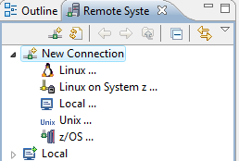
Notice that you can also access the file systems on your local machine. In this case Local will allow you to access the files on this the lab computer

- Define a new connection
  - From the Remote System Explorer perspective select the Remote Systems view.
  - Click New Connection and select z/OS.
  - Right-click and choose New Connection. The New Remote z/OS System Connection window opens.
  - Select a profile name from the drop-down list. If this is your first time defining a remote connection, a window opens prompting you to create a new profile. On the New Remote z/OS System Connection window, the profile name you enter is displayed. If it is automatically populated use that value.
  - Enter the following values as indicated next to the dialog box below. Please note that in the RDz Remote Systems Connection dialog box below has the Host Name first (computer address you what to connect to) and the Connection Name second (the name you want this connection to be known as.)

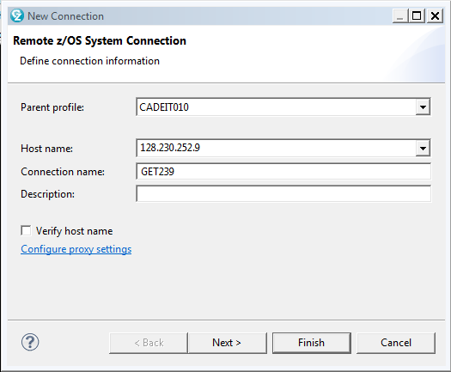
In RDz you will see the Host name listed first followed by the Connection Name
Host name
Enter the IP address of the system you want to connect to: 128.230.252.9
Connection name
Enter a short name you want to call your connection. For example, GET239
Description
Enter a description of your connection. This is a comments-only field
Verify host name
Select this check box to verify that the host name you entered is valid then click finish

- You should see a screen that looks similar to the one below.

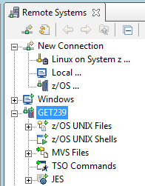
You should see your new connection. Here I used GET239. You are now ready to logon to the Enterprise Server using your new z/OS user ID.

To logon to the System z right click on your GET239 connection and select Connect. You will see an Enter Password dialog box like the one below. The very first time you will be asked to change your initial password to a new password.

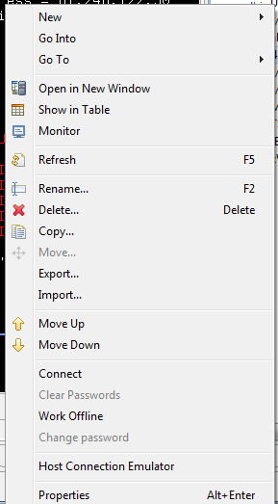
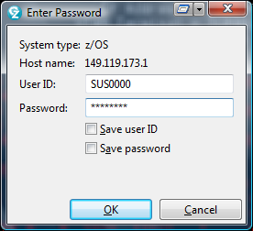

You have now successfully created a connection and a new session using the RDz’s GUI interface.

- To create another session using the Interactive Systems Programming Facility, or ISPF, right click on your new connection, GET239, you will see a dialog box like the one below. Click on Host Connection Emulator Support.

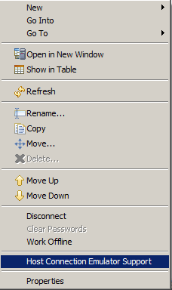

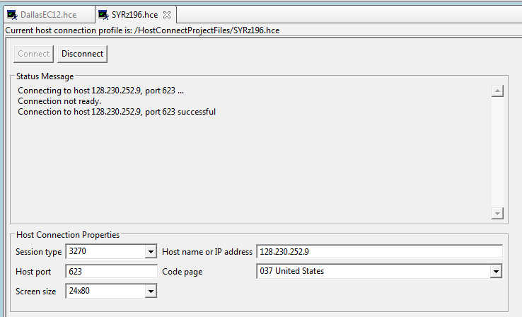
1. Change Host Port from 23 to 623. Save this setting by clicking save on the Tool bar
2. Close this connection and re-launch the Host Connection Emulator
- or -
Click disconnect and then click Connect

- Upon re-launch you will see a screen that looks like the one below. This is the z/OS splash or Welcome Page. This is the screen you will use to logon to the System z.

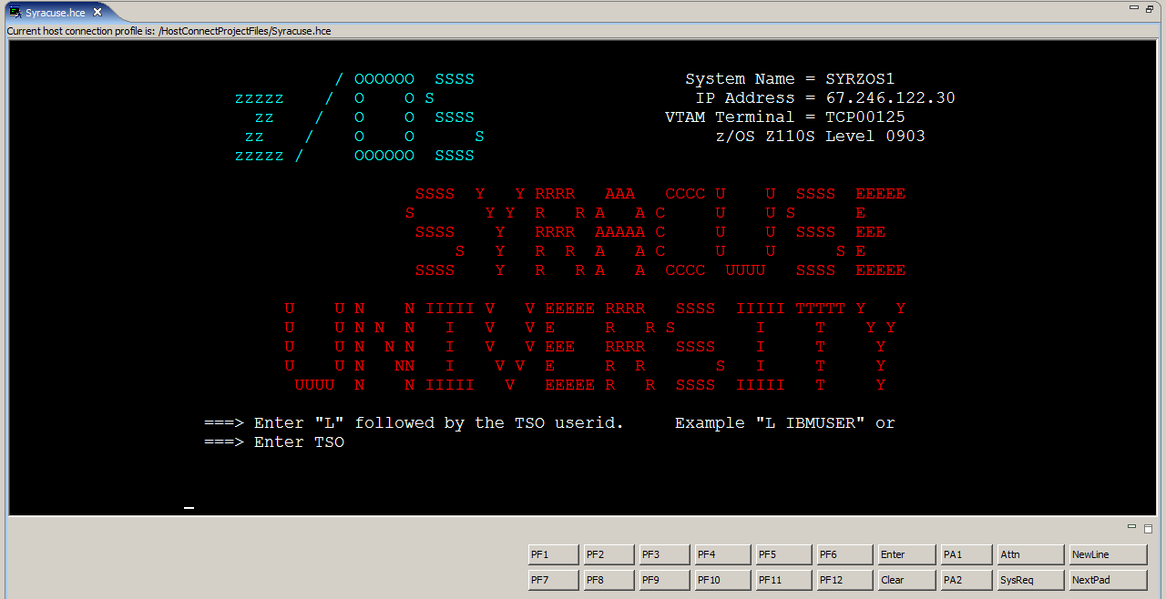

- Once here you can connect to z/OS by entering:

L <your ID> then press enter which will take you to the screen where you enter your password. L is an abbreviation for LOGON, you can use either one.

Here is an example:

L SUS0037

- or -

LOGON SUS0037

Then, press enter, you will see the screen where you can add your password. Remember your initial password supplied earlier; you need to change this password in order to continue. Be sure to follow the password rules when creating a new password.

Note: If you have already changed your password via RDz in the previous steps you will not have to change your password again.

If you changed your password in the previous step you will not have to change it again. You can sign on using your new password. Only follow these steps if you haven’t already changed your password (enter your initial password then tab over to New Password type your new password then press enter. You will be prompted to confirm it.)

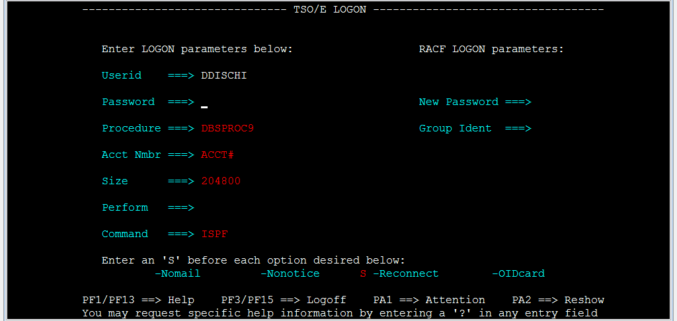

After you confirm your new password, you will see the following messages.
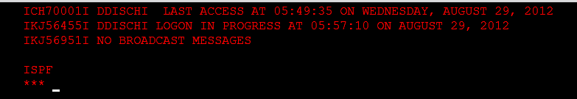

Press enter, you will then see the ISPF Primary Option Menu which looks like this:
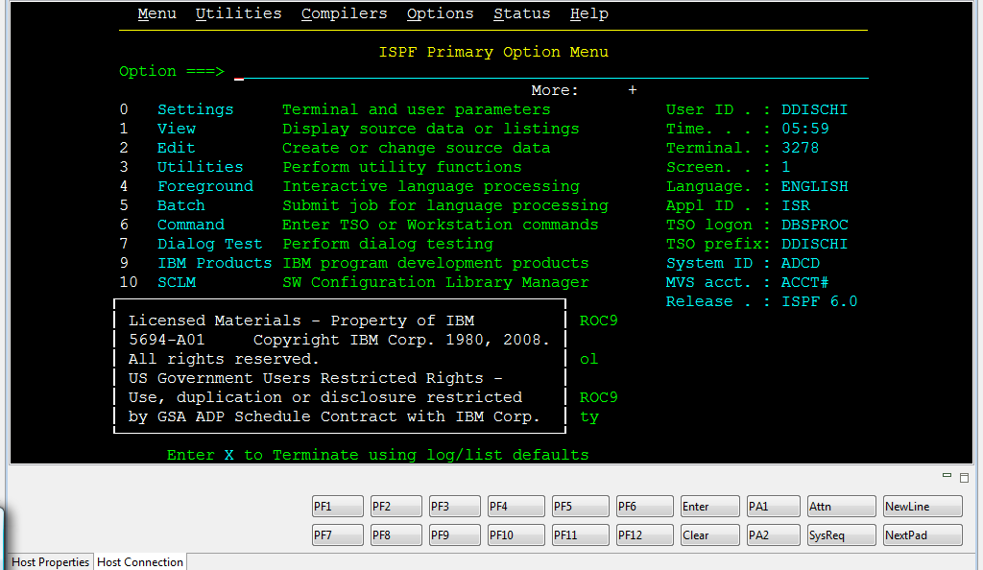

Congratulations, you have just created two connections and two sessions. You are ready to work on an Enterprise Server. You can use either the GUI interface or the text Menu interface or both.

